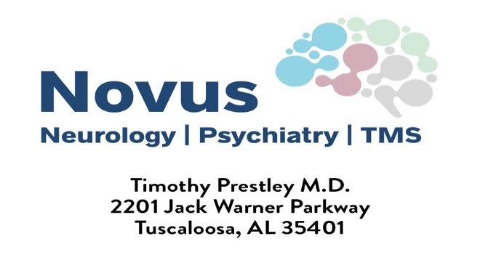
Phone: 205-523-5618 Fax: 659-210-3460
Please Print Legibly Date:_____________________
Patient Name:____________________________________________________ DOB:________________
Social Security #_____________________ Sex: Male Female PCP:__________________________
Address:__________________________________________apt/lot/unit #________________________
City/State/Zip:_________________________________________________________________________
Home #_____________________ Work#______________________ Cell#_________________________
Email:_____________________________________
Please send Copy of Insurance card (Front & Back)
Insurance (primary):___________________________________________________________________
Insurance (secondary):_________________________________________________________________
Referring Doctor:____________________________________ Referring email:___________________
Phone:_____________ Fax:_____________Physician Signature:_________________________________
Referral To:
Department (Circle One): Neurology | Psychiatry | TMS
Transcranial Magnetic Stimulation (TMS) is FDA approved and covered by all major insurance and Medicare for the treatment of major depressive disorder and other psychiatric and neurological conditions for patients age 18 years or older. An initial regime (i.e. 30-36 treatments) is administered by Novus in outpatient office setting if individual meets criteria.
Does the patient have one of the following ICD-10 Diagnosis Codes? F32.2 or F33.2
The requirements for medication trails differ between insurances but 2-4 failed Antidepressants with its classification (i.e. SSRI, SNRI, TCA, MAOI, other).Please list prior or current medications including max doses, approximate dates of therapy, and any side effects that the patient experienced ________________________________________________________________________________
_________________________________________________________________________________
Current Levels of Impairment (work, school, social, sleep, mood, etc) _________________________________________________________________________________
Has the patient tried at least one course of psychotherapy?_________________________________
Any prior ECT or TMS Treatments? ________________________________________________
Any history of seizures? ____________ Diagnosis of biopolar disorder?____________________
Any non-removable metal objects in or near head?______________ Electronic implants:_________
Any Active Neurological Disorder or Psychotic Symptoms?_______________

Please send records and insurance referral (if required) along with this referral. Appointment will not be made until records and insurance referral are received.
Internal Use FAXED:____________
Scheduled Appointment Time: _____/______/______ @______:______ w/Dr.____________________
Pt Notified ____/_____/______ @_____:______ by:________________________________________

